EXPERIMENT 1

Aim: To create an interactive diagram using Figma that illustrates the components of a basic cellular system and explains their functions.
Procedure:
- Open Figma and create a new design file.
- Draw shapes to represent the Mobile Station (MS), Base Transceiver Station (BTS), Mobile Switching Center (MSC), Home Location Register (HLR), PSTN, and Internet.
- Arrange the components properly on the canvas.
- Connect the components using lines and arrows to show communication flow.
- Add labels, colors, and icons to identify each component.
- Make the components interactive by adding clickable elements, tooltips, or notes explaining their functions.
- Save the design and preview the diagram.
OUTPUT: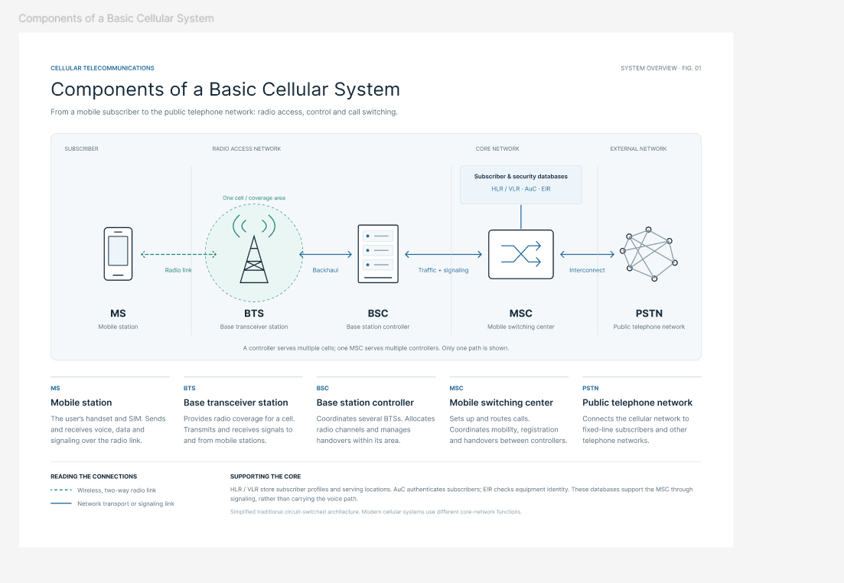
FIGMALINK: https://www.figma.com/design/ED1qcVpNfWi2Zuft4amJyZ/Untitled?node-id=7-2&p=f&t=agFau8l2OnHdtdLK-0
RESULT:
Thus, an interactive diagram illustrating the components of a basic cellular system was designed using Figma. The diagram explains the functions of each component and shows how they communicate with one another.

